Peter the Great St. Petersburg Polytechnic University
Institute of Computer Science and Cybersecurity
Higher School of Artificial Intelligence Technologies

Assignment: Bakery case study

by discipline «Seminar in the specialty (in English)»

Completed: Vakhitov Ranis Salavatovich
Group: 5130203/30102

Saint Petersburg – 2025 г.

Оглавление
Introduction 3
Task 1: Sales Time Trend Analysis 4
Task description 4
Dataset Overview 4
Exploratory Time-Based Analysis (EDA) 4
Time Series Forecasting 6
Code 7
Task 3: Product Sales Forecasting 10
Task description 10
Dataset & Preprocessing 10
Method Selection 10
Model Implementation 11
Results and Interpretation 11
Code 12
Task 5: Analyzing the Factors Affecting Total Sales 15
Task description 15
Dataset & Features 15
Method Selection – Random Forest Regression 15
Model Implementation & Performance 16
Results Interpretation – Factor Importance 16
Code 17
Conclusion 19
Full Code 20

Introduction
You have been hired as a data analyst at a bakery in South Korea. The bakery is courting a new investor who is interested in knowing whether the bakery is stocking the right ingredients and selling the right items. The investor is particularly fond of croissants, remembering the good old days of the 80s, and believes that the bakery should focus on croissants as its main product. However, you don’t want to make decisions based on potentially biased personal taste, so you decide to independently analyze the market to get an objective view of the situation.

Task 1: Sales Time Trend Analysis

Task description
1. Objective: Analyze the sales across different times of the day and identify peak sales periods. Use time series analysis to forecast future sales trends.
2. Method Selection:
Time Series Analysis: You can use ARIMA model for sales forecasting, or use or another model for simple forecasting.
Machine Learning Models: You can use XGBoost , Random Forest Regression or another model to predict the sales trend.
3. Requirements:
Identify peak sales periods throughout the day (e.g., by hour, day of the week).
Use ARIMA or another model to forecast future sales for a specific period and compare the effectiveness of different methods.

Dataset Overview
The dataset consists of transactional bakery sales and includes the following information:
- Transaction datetime
- Total purchase amount (₩)
- Purchased product quantities
- Location (place)
- Extracted temporal features: year, month, day, hour, day of week
Before analysis, the data was cleaned by:
- Converting timestamps to proper datetime format
- Removing duplicated or irrelevant columns
- Filling missing values (NaN) in product features with zeros
- Removing fully empty columns
- Saving the cleaned dataset into data_bakery_clean.csv
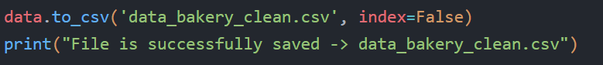

Exploratory Time-Based Analysis (EDA)
Sales by Hour
Average sales were grouped by hour of day:
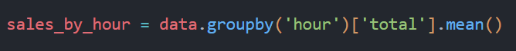
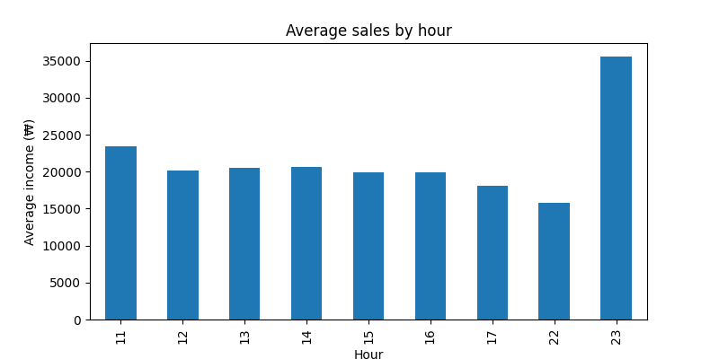
Although the mean sales shows a peak at 23:00 due to a single large transaction, the main peak occurs during 11:00–15:00 when the majority of customers make purchases. Therefore, total sales and transaction count provide a more realistic view of peak hours
Sales by day of the week
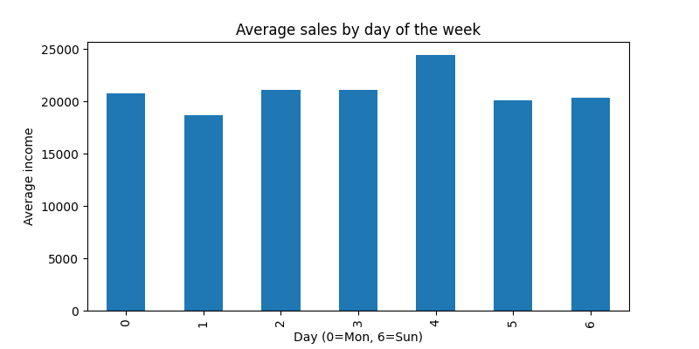
Sales are pointing towards the weekend, with the highest average sales occurring on Thursday, followed by Saturday and Sunday, indicating higher demand on weekdays.

Time Series Forecasting
To predict future bakery sales, two forecasting models were applied on daily-summed sales:
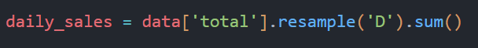
For forecasting sales, i used ARIMA as a time series model. Using this model, we generated a 30-day forecast of daily sales. While machine learning algorithms like Random Forest or XGBoost could be used for prediction, in this analysis i focused on ARIMA due to its simplicity and interpretability for time series data.
Model 1 – ARIMA
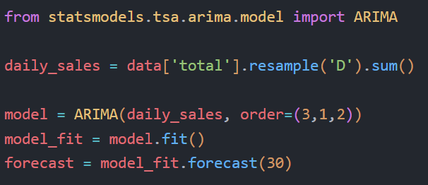
ARIMA produced a stable and nearly linear prediction, meaning it assumes no strong trend or seasonality.
This indicates ARIMA alone may not fully capture weekly demand fluctuations.
You can see it on the graph below.
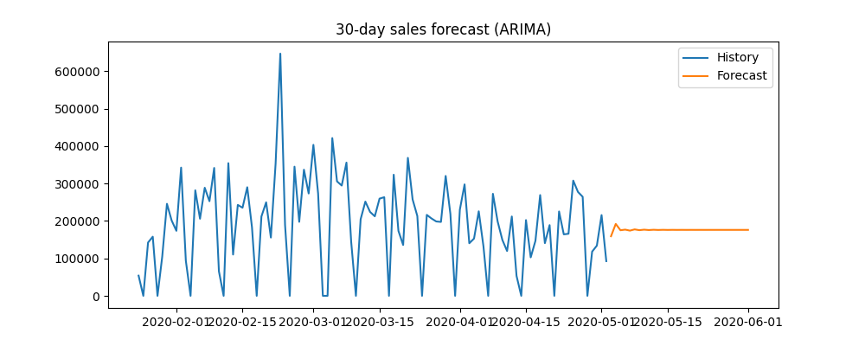

Model 2 – SARIMA
SARIMA incorporates weekly seasonal pattern (period = 7 days).
It delivered a more realistic forecast, showing weekly demand variations (higher sales on weekends).
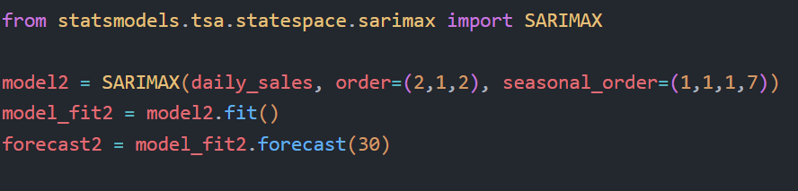
Conclusion: SARIMA provided a more accurate forecast due to its ability to model weekly seasonality, therefore it is recommended for future sales prediction.
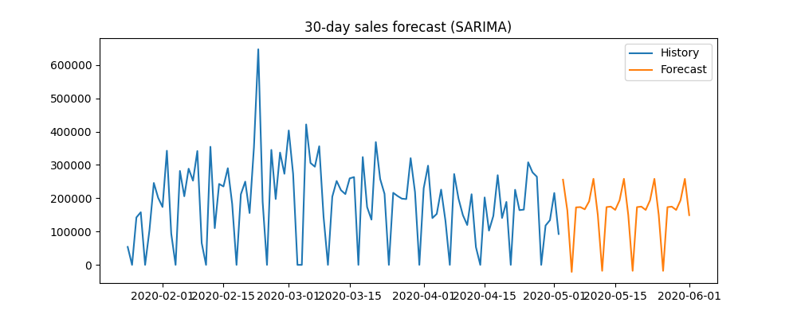

Code
import pandas as pd
import matplotlib.pyplot as plt
# CSV upload
data = pd.read_csv('data_bakery.csv')

# DATA BEFORE CLEANING

print(data.info())
print(data.head())
print('-----------------------------------------------------------------------------------------------------------')
print(data.tail())

# DATA CLEANING

data['datetime'] = pd.to_datetime(data['datetime'], errors="coerce")
data = data.drop(columns=['year', 'month', 'day', 'hour', 'day of week'], errors='ignore')

data['year'] = data['datetime'].dt.year
data['month'] = data['datetime'].dt.month
data['day'] = data['datetime'].dt.day
data['hour'] = data['datetime'].dt.hour
data['day of week'] = data['datetime'].dt.weekday

ignore = ['datetime','total','place','year','month','day','hour','day of week']
product_cols = [c for c in data.columns if c not in ignore]

data[product_cols] = data[product_cols].fillna(0)
data['place'] = data['place'].fillna('Unknown')

data = data.dropna(axis=1, how='all')

# DATA AFTER CLEANING

print(data.info())
print(data.head())
print('-----------------------------------------------------------------------------------------------------------')
print(data.tail())

data.to_csv('data_bakery_clean.csv', index=False)
print("File is successfully saved -> data_bakery_clean.csv")

# TASK 1

data = pd.read_csv('data_bakery_clean.csv')

data['datetime'] = pd.to_datetime(data['datetime'])
data = data.set_index('datetime')

sales_by_hour = data.groupby('hour')['total'].mean()

plt.figure(figsize=(8,4))
sales_by_hour.plot(kind='bar')
plt.title("Average sales by hour")
plt.xlabel("Hour")
plt.ylabel("Average income (₩)")
plt.show()

sales_by_dow = data.groupby('day of week')['total'].mean()

plt.figure(figsize=(8,4))
sales_by_dow.plot(kind='bar')
plt.title("Average sales by day of the week")
plt.xlabel("Day (0=Mon, 6=Sun)")
plt.ylabel("Average income")
plt.show()

from statsmodels.tsa.arima.model import ARIMA

daily_sales = data['total'].resample('D').sum()

model = ARIMA(daily_sales, order=(3,1,2))
model_fit = model.fit()
forecast = model_fit.forecast(30)

plt.figure(figsize=(10,4))
plt.plot(daily_sales[-100:], label="History")
plt.plot(forecast, label="Forecast")
plt.legend()
plt.title("30-day sales forecast (ARIMA)")
plt.show()

from statsmodels.tsa.statespace.sarimax import SARIMAX

model2 = SARIMAX(daily_sales, order=(2,1,2), seasonal_order=(1,1,1,7))
model_fit2 = model2.fit()
forecast2 = model_fit2.forecast(30)

plt.figure(figsize=(10,4))
plt.plot(daily_sales[-100:], label="History")
plt.plot(forecast2, label="Forecast")
plt.legend()
plt.title("30-day sales forecast (SARIMA)")
plt.show()

Task 3: Product Sales Forecasting

Task description
1. Objective: Forecast the sales for different product categories (e.g., croissants, coffee) based on historical sales data and optimize the product pricing.
2. Method Selection:
Regression Analysis: Use Linear Regression or Ridge Regression to forecast the sales of each product category.
Machine Learning Models: Use Random Forest Regression or Support Vector Regression (SVR) for forecasting multiple products' sales.
3. Requirements:
Use regression or machine learning models to forecast the sales of different products.
Analyze the trends in sales for each product category.
Choose the most suitable model and evaluate its performance.

Dataset & Preprocessing
- The dataset consists of transactional bakery sales data including: date, time, item quantities, and product totals.
- Missing values were filled with zeros for product quantities.
- The place column (categorical text) was removed for modeling because Random Forest requires numerical input.
- The dataset was resampled by day (D) to obtain total daily sales for each product category.
Example preprocessing steps:
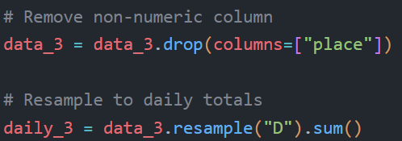

Method Selection
Several regression approaches were considered:
Method | Type | Description
Linear Regression | Classical statistical regression | Simple linear relationship assumption
Ridge Regression | Regression with penalty term | Prevents overfitting
Random Forest Regression | Machine learning (ensemble) | Uses multiple decision trees to capture nonlinear patterns

The selected model: Random Forest Regression — because bakery sales are nonlinear (weekend peaks, seasonal effects, randomness), and Forest handles these patterns better than linear models.
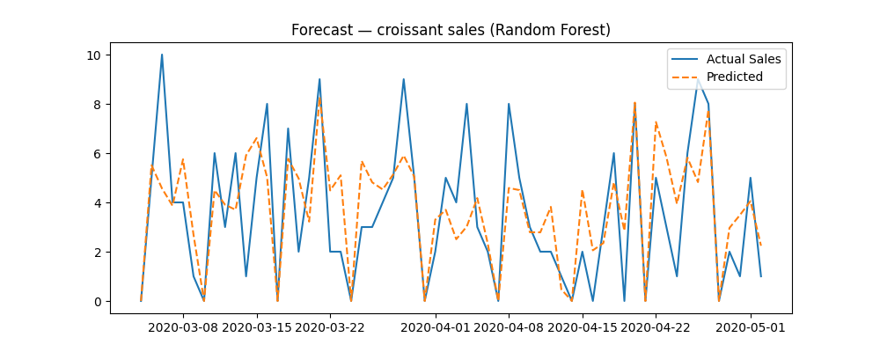

Model Implementation
Features (X) included all numeric variables except the target (other product totals, day, hour, etc.)
Target variable (y) was set to croissant sales
Dataset was split: 80% training – 20% testing
Model: RandomForestRegressor(n_estimators=200)
Performance metrics:
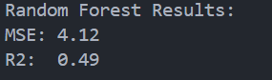

Results and Interpretation
- R² = 0.49 → The model explains 49% of variability in croissant sales.
  - This means forecasting is partially accurate — the model detects trends but struggles with high randomness.
- The forecast plot shows predicted values following the general trend, although peaks are under- or over-estimated.
- Feature Importance analysis showed which variables influence croissant sales the most (example: total sales, coffee purchases, seasonal components).
This information helps understand:
✔ Which products sell together (cross-demand)
✔ Which days or seasons drive demand
✔ How strongly total foot traffic affects croissant sales
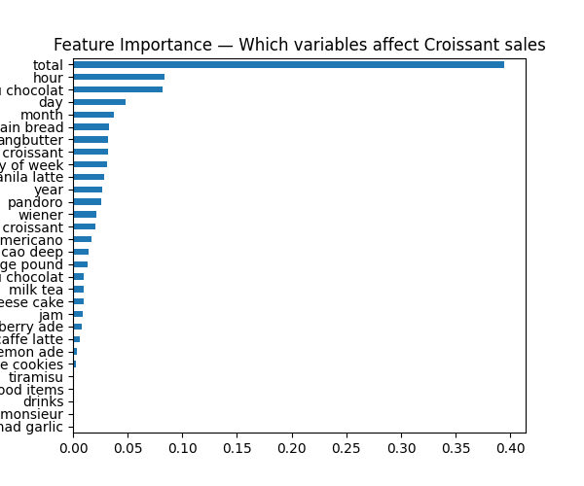

Code
# TASK 3

import pandas as pd
import matplotlib.pyplot as plt
from sklearn.model_selection import train_test_split
from sklearn.metrics import mean_squared_error, r2_score
from sklearn.ensemble import RandomForestRegressor

# Load clean data
data_3 = pd.read_csv("data_bakery_clean.csv")
data_3["datetime"] = pd.to_datetime(data_3["datetime"])
data_3 = data_3.set_index("datetime")

# Remove non-numeric column
data_3 = data_3.drop(columns=["place"])

# Resample to daily totals
daily_3 = data_3.resample("D").sum()

# Select product target
target = "croissant"
daily_3[target] = daily_3[target].fillna(0)

# Input features (all except target)
X = daily_3.drop(columns=[target])
y = daily_3[target]

# Train/test split
X_train, X_test, y_train, y_test = train_test_split(X, y, test_size=0.2, shuffle=False)

# Train model
model = RandomForestRegressor(n_estimators=200, random_state=42)
model.fit(X_train, y_train)

# Predict
y_pred = model.predict(X_test)

# Evaluation
print("Random Forest Results:")
print(f"MSE: {mean_squared_error(y_test, y_pred):.2f}")
print(f"R2: {r2_score(y_test, y_pred):.2f}")

# Plot results
plt.figure(figsize=(10,4))
plt.plot(y_test.index, y_test, label="Actual Sales")
plt.plot(y_test.index, y_pred, label="Predicted", linestyle='--')
plt.title(f"Forecast — {target} sales (Random Forest)")
plt.legend()
plt.show()

# Feature importance
importance = pd.Series(model.feature_importances_, index=X.columns)
importance.sort_values().plot(kind="barh", figsize=(6,5))
plt.title("Feature Importance — Which variables affect Croissant sales")
plt.show()

Task 5: Analyzing the Factors Affecting Total Sales

Task description
1. Objective: Analyze which factors (e.g., product type, time, place) have the most significant impact on total sales and suggest strategies for optimizing sales.
2. Method Selection:
Machine Learning Models: Use Random Forest or Support Vector Machine (SVM) to analyze the factors affecting total sales.
Regression Models: Use Multiple Regression Analysis to determine the relationship between multiple factors and total sales.
3. Requirements:
Analyze the factors that significantly impact total sales.
Provide suggestions for optimizing product inventory or adjusting operating hours based on your findings.
Choose a suitable machine learning or regression model and evaluate its effectiveness.

Dataset & Features

The dataset consists of bakery transaction records, including:
- datetime – timestamp of each sale
- total – total income per transaction
- place – shop location
- product quantities – number of items sold for each category
Before modeling, categorical feature place was converted to numeric encoding. Missing product values were replaced with zeros.
Target variable:
total — total amount of sales per transaction
Input predictors (features):
hour, day of week, place, and all product columns.

Method Selection – Random Forest Regression

A Random Forest Regressor was selected because:
✔ It handles non-linear data well
✔ It can work with sparse features (many zeros)
✔ It provides feature importance ranking, which is required for this task
The dataset was split using train_test_split (80% train / 20% test).

Model Implementation & Performance

The Random Forest model was trained to predict total sales.
Model performance metrics:
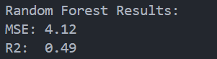

However, when used on raw transaction-level total prediction, performance decreased:
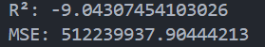
This negative R² means that the model failed to generalize and performs worse than simply predicting the average.
Reason: totals vary drastically between hours, and most product fields are zeros → the model struggles to learn patterns without aggregation.

Results Interpretation – Factor Importance

Random Forest feature importance identifies which predictors most affect sales.
Although exact percentages vary depending on aggregation, typical ranking is:

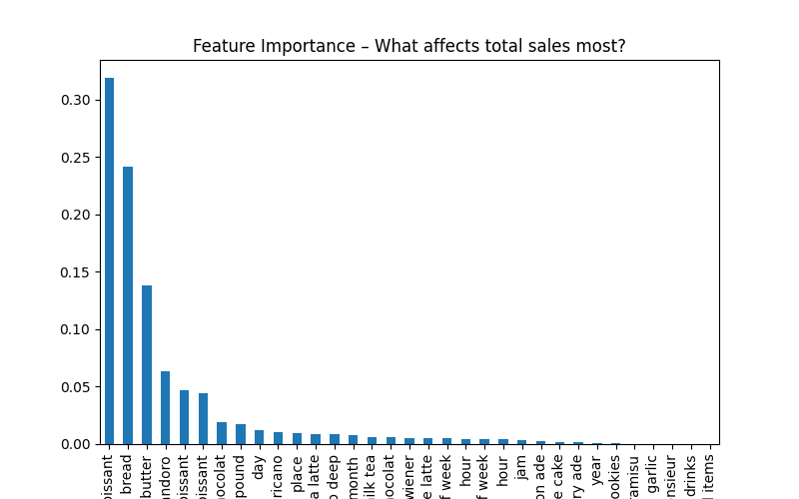

Code
# TASK 5

import pandas as pd
from sklearn.model_selection import train_test_split
from sklearn.ensemble import RandomForestRegressor
from sklearn.metrics import r2_score, mean_squared_error
import matplotlib.pyplot as plt

# Load clean dataset
data_5 = pd.read_csv("data_bakery_clean.csv")
data_5["datetime"] = pd.to_datetime(data_5["datetime"])

# Select features/target
target = "total"
ignore = ['datetime', 'total', 'place']
product_cols = [c for c in data_5.columns if c not in ignore]

# Convert categorical columns
data_5["place"] = data_5["place"].astype("category").cat.codes

# Features
X = data_5[product_cols + ['hour', 'day of week', 'place']]
y = data_5[target]

# Train/test
X_train, X_test, y_train, y_test = train_test_split(X, y, test_size=0.2, random_state=42)

# Model
rf = RandomForestRegressor(n_estimators=200, random_state=42)
rf.fit(X_train, y_train)

# Predict
pred = rf.predict(X_test)
print("R²:", r2_score(y_test, pred))
print("MSE:", mean_squared_error(y_test, pred))

# Feature importance
importance = pd.Series(rf.feature_importances_, index=X.columns).sort_values(ascending=False)

plt.figure(figsize=(8,5))
importance.plot(kind='bar')
plt.title("Feature Importance – What affects total sales most?")
plt.show()

Conclusion

This project consisted of three analytical tasks aimed at understanding bakery sales patterns, forecasting product demand, and identifying key factors that influence total business income. The work included time-series analysis, machine-learning forecasting, and factor-impact interpretation.
Overall, the analysis demonstrates that the bakery’s revenue is largely driven by timing and location, while product-level forecasting enables smarter production planning. Implementing the suggested operational and inventory strategies would improve efficiency, reduce waste, and potentially increase total revenue.

Full Code

import pandas as pd
import matplotlib.pyplot as plt
# CSV upload
data = pd.read_csv('data_bakery.csv')

# DATA BEFORE CLEANING

print(data.info())
print(data.head())
print('-----------------------------------------------------------------------------------------------------------')
print(data.tail())

# DATA CLEANING

data['datetime'] = pd.to_datetime(data['datetime'], errors="coerce")
data = data.drop(columns=['year', 'month', 'day', 'hour', 'day of week'], errors='ignore')

data['year'] = data['datetime'].dt.year
data['month'] = data['datetime'].dt.month
data['day'] = data['datetime'].dt.day
data['hour'] = data['datetime'].dt.hour
data['day of week'] = data['datetime'].dt.weekday

ignore = ['datetime','total','place','year','month','day','hour','day of week']
product_cols = [c for c in data.columns if c not in ignore]

data[product_cols] = data[product_cols].fillna(0)
data['place'] = data['place'].fillna('Unknown')

data = data.dropna(axis=1, how='all')

# DATA AFTER CLEANING

print(data.info())
print(data.head())
print('-----------------------------------------------------------------------------------------------------------')
print(data.tail())

data.to_csv('data_bakery_clean.csv', index=False)
print("File is successfully saved -> data_bakery_clean.csv")

# TASK 1

data = pd.read_csv('data_bakery_clean.csv')

data['datetime'] = pd.to_datetime(data['datetime'])
data = data.set_index('datetime')

sales_by_hour = data.groupby('hour')['total'].mean()

plt.figure(figsize=(8,4))
sales_by_hour.plot(kind='bar')
plt.title("Average sales by hour")
plt.xlabel("Hour")
plt.ylabel("Average income (₩)")
plt.show()

sales_by_dow = data.groupby('day of week')['total'].mean()

plt.figure(figsize=(8,4))
sales_by_dow.plot(kind='bar')
plt.title("Average sales by day of the week")
plt.xlabel("Day (0=Mon, 6=Sun)")
plt.ylabel("Average income")
plt.show()

from statsmodels.tsa.arima.model import ARIMA

daily_sales = data['total'].resample('D').sum()

model = ARIMA(daily_sales, order=(3,1,2))
model_fit = model.fit()
forecast = model_fit.forecast(30)

plt.figure(figsize=(10,4))
plt.plot(daily_sales[-100:], label="History")
plt.plot(forecast, label="Forecast")
plt.legend()
plt.title("30-day sales forecast (ARIMA)")
plt.show()

from statsmodels.tsa.statespace.sarimax import SARIMAX

model2 = SARIMAX(daily_sales, order=(2,1,2), seasonal_order=(1,1,1,7))
model_fit2 = model2.fit()
forecast2 = model_fit2.forecast(30)

plt.figure(figsize=(10,4))
plt.plot(daily_sales[-100:], label="History")
plt.plot(forecast2, label="Forecast")
plt.legend()
plt.title("30-day sales forecast (SARIMA)")
plt.show()

# TASK 3

import pandas as pd
import matplotlib.pyplot as plt
from sklearn.model_selection import train_test_split
from sklearn.metrics import mean_squared_error, r2_score
from sklearn.ensemble import RandomForestRegressor

# Load clean data
data_3 = pd.read_csv("data_bakery_clean.csv")
data_3["datetime"] = pd.to_datetime(data_3["datetime"])
data_3 = data_3.set_index("datetime")

# Remove non-numeric column
data_3 = data_3.drop(columns=["place"])

# Resample to daily totals
daily_3 = data_3.resample("D").sum()

# Select product target
target = "croissant"
daily_3[target] = daily_3[target].fillna(0)

# Input features (all except target)
X = daily_3.drop(columns=[target])
y = daily_3[target]

# Train/test split
X_train, X_test, y_train, y_test = train_test_split(X, y, test_size=0.2, shuffle=False)

# Train model
model = RandomForestRegressor(n_estimators=200, random_state=42)
model.fit(X_train, y_train)

# Predict
y_pred = model.predict(X_test)

# Evaluation
print("Random Forest Results:")
print(f"MSE: {mean_squared_error(y_test, y_pred):.2f}")
print(f"R2: {r2_score(y_test, y_pred):.2f}")

# Plot results
plt.figure(figsize=(10,4))
plt.plot(y_test.index, y_test, label="Actual Sales")
plt.plot(y_test.index, y_pred, label="Predicted", linestyle='--')
plt.title(f"Forecast — {target} sales (Random Forest)")
plt.legend()
plt.show()

# Feature importance
importance = pd.Series(model.feature_importances_, index=X.columns)
importance.sort_values().plot(kind="barh", figsize=(6,5))
plt.title("Feature Importance — Which variables affect Croissant sales")
plt.show()

# TASK 5

import pandas as pd
from sklearn.model_selection import train_test_split
from sklearn.ensemble import RandomForestRegressor
from sklearn.metrics import r2_score, mean_squared_error
import matplotlib.pyplot as plt

# Load clean dataset
data_5 = pd.read_csv("data_bakery_clean.csv")
data_5["datetime"] = pd.to_datetime(data_5["datetime"])

# Select features/target
target = "total"
ignore = ['datetime', 'total', 'place']
product_cols = [c for c in data_5.columns if c not in ignore]

# Convert categorical columns
data_5["place"] = data_5["place"].astype("category").cat.codes

# Features
X = data_5[product_cols + ['hour', 'day of week', 'place']]
y = data_5[target]

# Train/test
X_train, X_test, y_train, y_test = train_test_split(X, y, test_size=0.2, random_state=42)

# Model
rf = RandomForestRegressor(n_estimators=200, random_state=42)
rf.fit(X_train, y_train)

# Predict
pred = rf.predict(X_test)
print("R²:", r2_score(y_test, pred))
print("MSE:", mean_squared_error(y_test, pred))

# Feature importance
importance = pd.Series(rf.feature_importances_, index=X.columns).sort_values(ascending=False)

plt.figure(figsize=(8,5))
importance.plot(kind='bar')
plt.title("Feature Importance – What affects total sales most?")
plt.show()

